**Unit: Manual Motor Controls Quiz: 5**

**Single-Phase and Three Phase Motors CLO#: 1**

Name ______________________________ Date ______________

**Instructions**

1. Which component of a three-phase motor produces the rotating magnetic field?
2. The speed of a squirrel cage induction motor depends on;
3. What is the purpose of the laminated iron plates within the rotor?
4. Motors in the US are rated by;
5. Motors in Europe are rated by;
6. If a 3HP motor has a service factor of 1.25, what HP can the motor be loaded to?
7. What is motor slip?
8. What is the effect of operating a motor at a temperature greater than its insulating class?
9. What is motor *Efficiency*?
10. When a motor is rated for *Inverter Duty*, what does that indicate?
11. All NEMA motor nameplates are the same.
    1. True
    2. False
12. What does a motors *Type* signify?
13. What does a motors *Code* letter signify?
14. A motors *Power Factor (PF)* is useful to determine;
15. A motor is rated at 480V @ 60 Hz. If this motor is installed in England, how will the motor speed be affected?

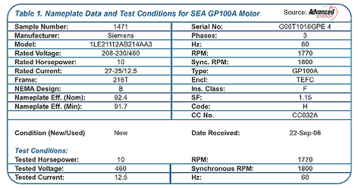

1. What is the horsepower for this motor? __________
2. How many watts should this motor dissipate? ______________
3. What nominal voltage level would you use to connect to this motor to its higher voltage setting? ___________
4. What is the acceptable range of voltage input to this motor if it is connected to it’s lowest voltage range? _______ to _______
5. What is the RPM for this motor? ____________
6. If the motor is connected to its higher source voltage it will spin at a higher RPM?
   1. True
   2. False
7. What is the service factor of this motor? __________
8. What is the maximum horsepower output of this motor? _________
9. It is safe to run this motor at its max HP for extended periods of time.
   1. True
   2. False
10. Draw a schematic to the right of the motor contactor that indicates its internal components.



1. Compose a truth table and construct the formulas for the control schematic below. HINT: There shall be a formula for the CR1 and for the red light. (CR1 and green light formulas are the same)

